Supplementary Information
Labrador Sea freshening at 8.5 ka BP caused by
Hudson Bay Ice Saddle collapse (Lochte et al.)

Supplementary Information
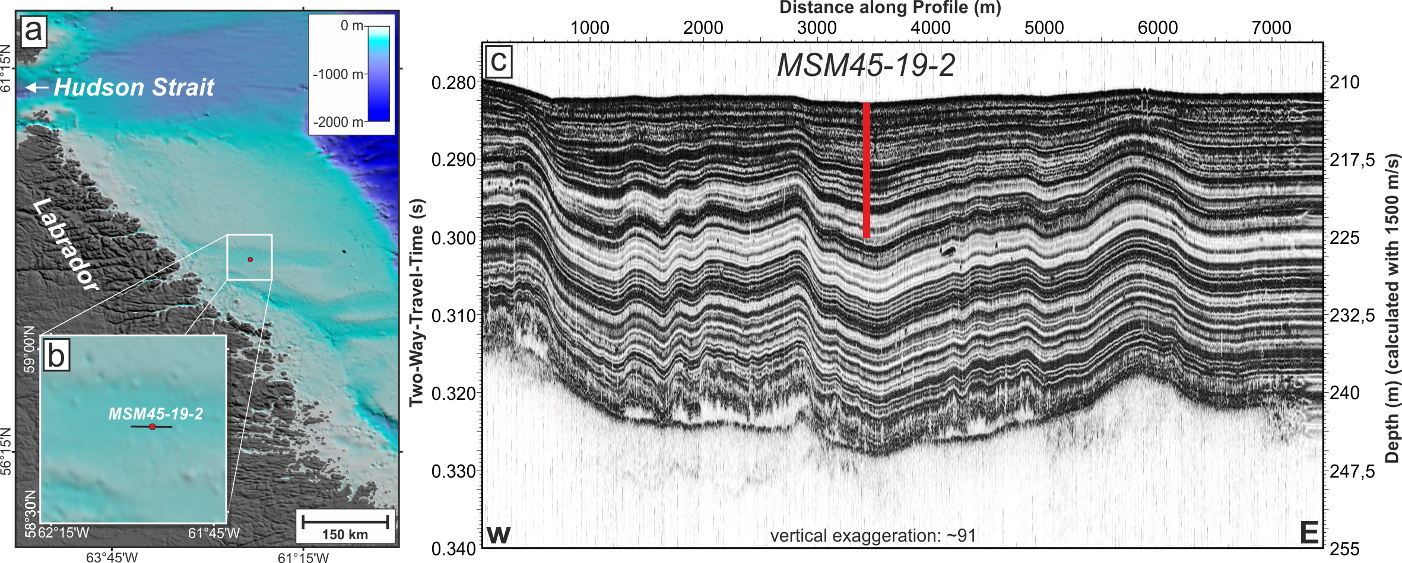Supplementary Figure 1 | Core location on the northern Labrador Shelf. a) Bathymetric map of the survey area with core location. b) Zoom-in to the core location of MSM45-19-2. c) Hull-mounted PARASOUND P70 echogram across the core location MSM45-19-2 displayed with a vertical exaggeration of ~91. The echogram shows well-stratified and undisturbed sedimentary units within the upper 40 ms (~30 m).

Supplementary Table 1: Twenty-one AMS radiocarbon dates obtained from mixed benthic foraminifera. Reported radiocarbon dates were calibrated in Calib7.1¹ based on the Marine13 dataset² with reservoir corrections (ΔR) of 144 ± 38 and 344 ± 38. The youngest sample KIA 51535 could not be calibrated with the Marine13 dataset. We assume an age younger than 1950 AD. Six AMS dates between 1043 and 1273 cm depth were excluded from linear interpolation due to anomalously old calendar ages (in italic).
AMS | Depth | Reported | Reservoir | 1 sigma | 2 sigma | Median
laboratory | (cm) | ¹⁴C age | correction | age range | age range | probability
number |  | (yr BP) | ΔR (¹⁴C yr) | (cal yr BP) | (cal yr BP) | age (cal yr BP)
KIA 51535 | 3 | 204 ± 26 | 144 ± 38 |  |  | 0
KIA 51536 | 103 | 2563 ± 25 | 144 ± 38 | 1989 – 2116 | 1915 – 2195 | 2055
KIA 51537 | 203 | 4702 ± 35 | 144 ± 38 | 4697 – 4832 | 4583 – 4832 | 4761
KIA 51538 | 303 | 5570 ± 34 | 144 ± 38 | 5740 – 5868 | 5665 – 5907 | 5799
KIA 51539 | 403 | 6318 ± 37 | 144 ± 38 | 6536 – 6677 | 6468 – 6741 | 6610
KIA 51540 | 503 | 6781 ± 36 | 144 ± 38 | 7118 – 7243 | 7010 – 7275 | 7169
KIA 51541 | 603 | 6989 ± 38 | 144 ± 38 | 7312 – 7414 | 7254 – 7457 | 7362
KIA 51542 | 703 | 7452 ± 39 | 344 ± 38 | 7539 – 7642 | 7474 – 7682 | 7584
KIA 51543 | 803 | 7546 ± 42 | 344 ± 38 | 7601 – 7720 | 7561 – 7790 | 7666
KIA 51544 | 903 | 7811 ± 40 | 344 ± 38 | 7864 – 7979 | 7795 – 8042 | 7926
KIA 51545 | 1003 | 8097 ± 45 | 344 ± 38 | 8163 – 8295 | 8073 – 8351 | 8225
KIA 52109 | 1013 | 8190 ± 40 | 344 ± 38 | 8256 – 8376 | 8179 – 8406 | 8311
KIA 52110 | 1023 | 8270 ± 40 | 344 ± 38 | 8330 – 8439 | 8282 – 8522 | 8388
KIA 52586 | 1033 | 8385 ± 40 | 344 ± 38 | 8424 – 8550 | 8377 – 8618 | 8495
KIA 52587 | 1043 | 8990 ± 40 | 344 ± 38 | 9254 – 9398 | 9145 – 9443 | 9317
KIA 52035 | 1048 | 8720 ± 40 | 344 ± 38 | 8880 – 9051 | 8753 – 9123 | 8964
KIA 51546 | 1103 | 8805 ± 44 | 344 ± 38 | 8988 – 9146 | 8947 – 9260 | 9079
KIA 51547 | 1203 | 8914 ± 50 | 344 ± 38 | 9112 – 9305 | 9030 – 9386 | 9213
KIA 52588 | 1233 | 9105 ± 70 | 344 ± 38 | 9356 – 9511 | 9231 – 9572 | 9425
KIA 52590 | 1273 | 8965 ± 40 | 344 ± 38 | 9220 – 9385 | 9116 – 9425 | 9287
KIA 52591 | 1303 | 8765 ± 50 | 344 ± 38 | 8949 – 9121 | 8805 – 8818ª | 9029
 |  |  |  |  | 8840 – 9240^{b}
Relative probabilities: a = 0.006; b = 0.994

Supplementary References
1 Stuiver, M. & Reimer, P. J. Extended 14C Data Base and Revised CALIB 3.0 14C Age Calibration Program. Radiocarbon 35, 215-230, doi:10.1017/S0033822200013904 (1993).
2 Reimer, P. J. et al. IntCal13 and Marine13 Radiocarbon Age Calibration Curves 0–50,000 Years cal BP. Radiocarbon 55, 1869-1887, doi:10.2458/azu_js_rc.55.16947 (2013).

